Jesus’ family – Geometrical Forms for Maternal, Kindergarten and First Cycle
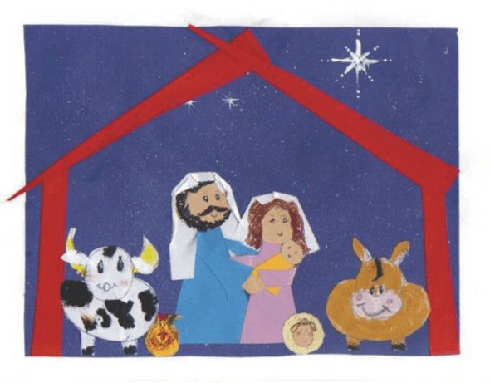
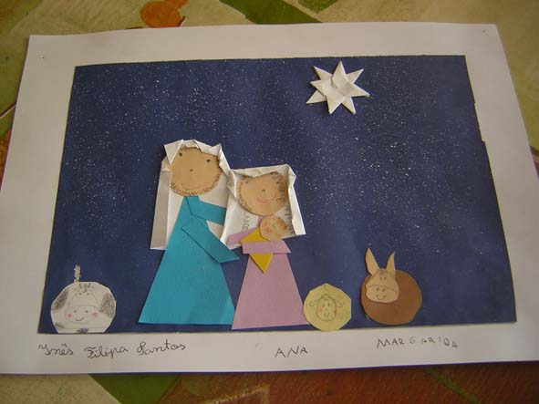

1) The dark blue paper was sprinkled with white gouache, using an old toothbrush;
2) Trim, using different colorful papers, three triangles in different sizes to create the bodies of Joseph, Mary and baby Jesus;
3) Trim three circles in sizes proportional to the triangles to create the heads;
4) Trim two thin rectangles for the arms of Joseph and Mary, and two little circles for the hands.
5) The mantle is optional – cut two rectangles with one of the extremes to be made in the shape of an arch;
6) The little animals could be made with circular figures (see model of animals in 3D), as from the example above mentioned. (a cow and a donkey were drawn and colored by 7 year old Peter in this model). The rooster could be made from the drawing of a triangle with 2 rounded ends.
7) The children will glue and draw the eyes, mouth, nose, beard and hair (we could glue wooden line or other material).
8) The cottage could be created from 4 wooden sticks or from 4 narrow rectangles cut out of paper, as from the model above.
9) The star was drawn using a toothpick and gouache; from the sketch of a cross.

